**WHATSAPP BOT**

**Overview**

A WhatsApp Bot is an automated program that interacts with users through WhatsApp messages. It can reply to user queries, share information, or perform specific actions automatically without human help.

**Example**  
When a user sends “Hi”, the bot replies “Hello! How can I help you today?”

## ****Purpose****

The purpose of this bot is to:

* Automatically respond to common user messages.
* Save time in customer support or information sharing.
* Show how automation works using WhatsApp API.

## ****Tools and Technologies Used****

* **Programming Language:** Python
* **API:** WhatsApp Business API
* **Server:** Flask
* **Database (Optional):** SQLite / MongoDB (to store chat history)

**Architecture Workflow**

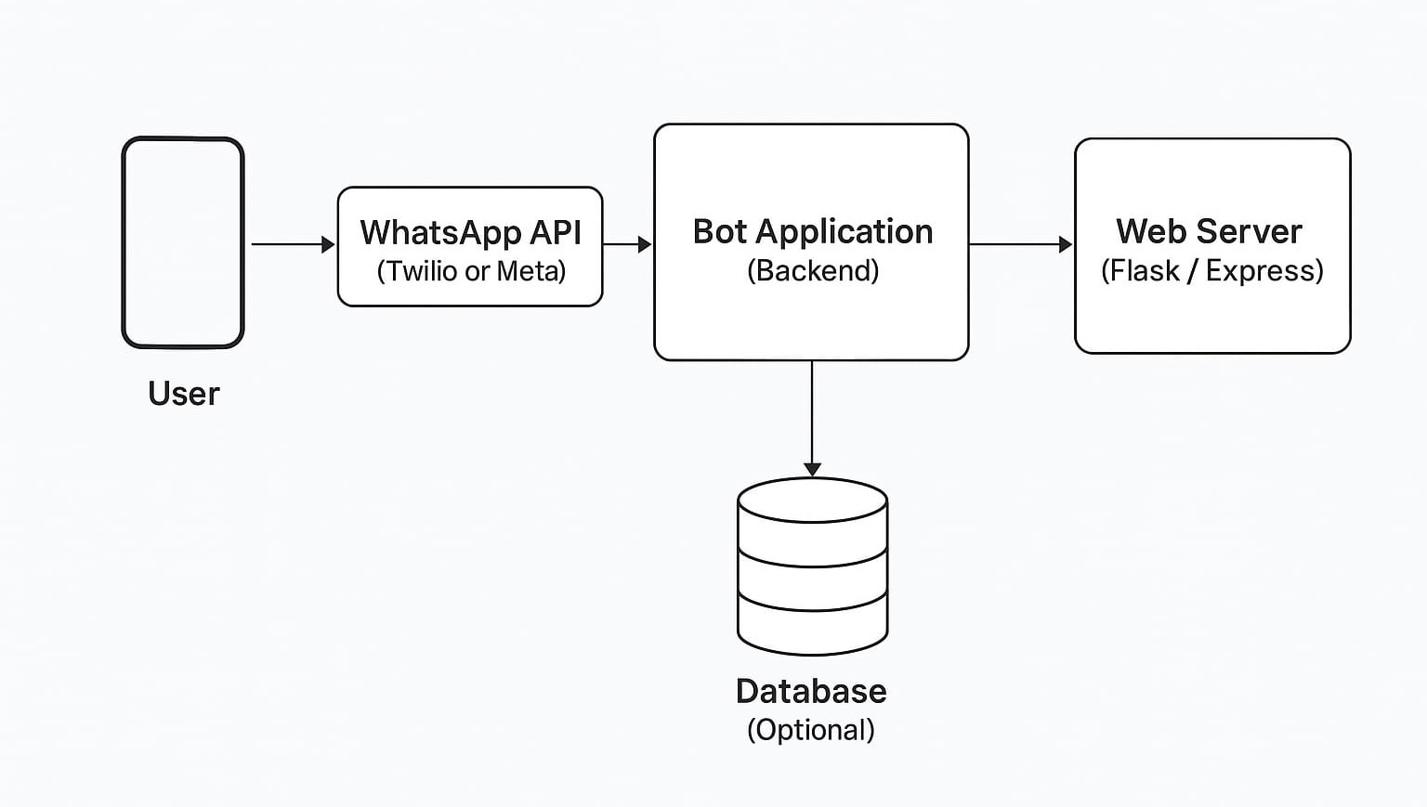

1. **User sends message** to the WhatsApp number.
2. **API receives the message** and sends it to the bot server.
3. **Bot processes** the message and prepares a reply.
4. **API sends the reply** back to the user on WhatsApp.

## ****Example Flow****

**User:** Hi  
**Bot:** Hello! I am your assistant. Type  
1. For Product Info   
2. For Support  
3. For Contact Details

**User:** 1  
**Bot:** Our product is a WhatsApp automation tool that helps small businesses communicate easily.

## ****Key Features****

* Automatic replies
* Custom message handling
* Simple keyword-based response
* Easy to deploy and scale

## ****Limitations****

* Requires internet connection
* Can’t start a conversation first (user must message first).

## ****Future Improvements****

* Add AI-based reply using ChatGPT API
* Create a web dashboard to monitor messages

## ****Conclusion****

The WhatsApp Bot project demonstrates how enterprise communication can be automated efficiently using APIs. It is scalable, easy to maintain, and provides a foundation for building advanced conversational systems.